AWPHD & WSHA Guide to Governance Education Portal
Member User Guide
1. How a member creates an account
1. Go to Governance Education portal
2. Click "Signup" in the upper righthand corner of the page
3. Complete the form
4. Click “Create account”
2. How a member logs in
1. Go to Governance Education portal
2. Click “Login” in the upper righthand corner of the page
3. Enter username and password
4. Click “Login”
3. How a member registers for a webinar
In Talent LMS a webinar is referred to as an ILT or Instructor-Led Training.
1. Log in to the Governance Education portal
2. Go to the Course catalog
3. Search for "WEBINAR NAME"
4. Click on the course name
5. Click on the blue "Start or resume course" button
6. Click the blue "Register" button

*After a member registers for a webinar, an automated email is sent from the Governance Education Portal:
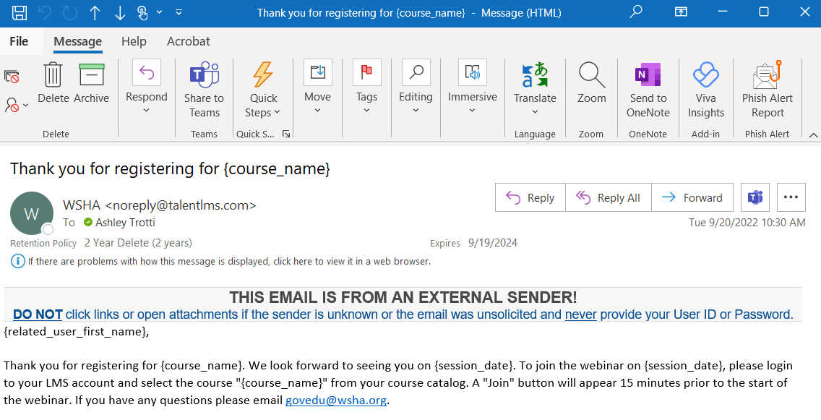

4. How a member accesses the webinar on the date/time of event
1. Login to the Governance Education portal
2. Go to the Course catalog
3. Search for "WEBINAR NAME"
4. Click on the course name
5. 15 minutes prior to the start of the webinar a "Join" link will appear. Click the "Join" link to join the webinar.
5. How a member watches previously recorded courses and earns points
Members have access to a library of previously recorded content that can be watched On Demand to earn points.
1. Login to the Governance Education portal
2. Go to the Course catalog
3. Click on the course name
4. Press the play button to watch the recording
5. IMPORTANT! Press the “Complete” button after watching the recording so the course is logged to your learner profile
*After a member presses the “Complete” button, an automated email is sent from Governance Education Portal:
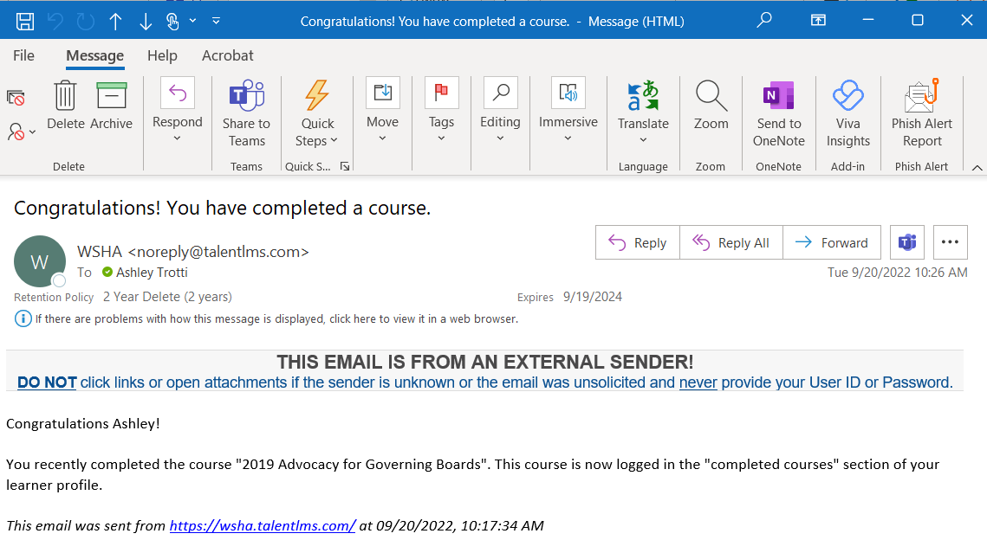
6. How a member logs a credit hour earned from an in-person event
AWPHD & WSHA can select sessions from in-person events to count for points towards Governance certification. If a member attends a session(s) at an in-person or virtual signature event that counts for credit the member can log that point in the Governance Education Portal.
1. Login to the Governance Education portal
2. Go to the Course catalog
3. Search for "SESSION NAME"
4. Click on the course name
5. Choose “Yes” to confirm attendance at the in-person or virtual session
6. Click “Submit test”

